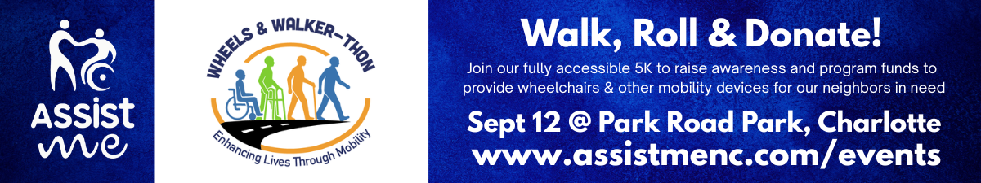
⭐ PEER-TO-PEER FUNDRAISING TOOL KIT

Thank you for joining our peer-to-peer fundraising team! We are excited to have you be a part of Assist ME’s 2026 Wheels & Walker-thon signature event. We’ve developed a checklist, social media, email and text content that you can customize with your team’s name, link and QR Code and then cut and paste as needed to build to your fundraising goal. Best of luck!

⭐ Fundraising Captain Intro
Your friends and family want to support you — they just need reminders. It’s normal. People pledge to donate, then get distracted and never make it onto your leaderboard. That’s why follow-ups matter.
Use the messages below to keep your team’s momentum strong. Add your team name, team link, or QR code, and don’t forget to share your fundraising goal. Clear goals motivate people to give.

⭐ Team Captain Checklist
We want to anticipate any processes or questions you may have, so here we go!
✔ Register and set up your team at https://givebutter.com/2026Walker-thon
✔ Select the “TICKETS & TEAMS” button and follow the prompts.
Additional instructions are within the event page details. If you need Givebutter.com support, click the down arrow beside your name in the top left corner and request Live Chat Support. You request “human agent” at any time during support hours.
✔ Create your team name…something memorable or catchy
You will use this name in your messaging and instruct your peers to allocate their donations to your team. You can win incentive gifts while donating to a great cause.
✔ Set your team goal
People give more when they know what you’re aiming for.
✔ Create your inspirational story: Passion wins the most pledges!
✔ Share your team link and/or QR code. Tips:
- Be sure to save the QR Code to your phone / photos or email it to yourself so it’s handy.
✔ Send your first message
Use one of the ready-made messages in the toolkit. Keep it simple. Helpful tips:
- When texting, first create and send your text (words only).
- Next, add your custom link or share an image such as a social media post
1) the custom link should automatically create a thumbnail image that can be clicked.
2) or share a social media image
- Bottom line: Make donating easy — one click, one scan.
✔ Follow up with reminders
Your closest supporters will forget — it’s normal. Gentle nudges work. Really, sometimes 3-5 nudges.

✔ Post on social media
A quick post boosts visibility and helps your team climb the leaderboard. Follow us, tag us or simply share from our social media pages!
✔ Thank donors immediately
A fast thank you encourages others to give – or give again if you are close to your goal!
✔ Celebrate milestones
Halfway to your goal? Hit your target? Tell people. Momentum inspires more giving.
✔ Stay competitive (in a fun way!)
Let your team know you’re aiming to raise the most money for mobility access. You might even win great incentive prizes in the process (stay tuned)!

⭐ COPY & PASTE FUNDRAISING MESSAGES:
(Choose any — mix, match, repeat as needed)
🚶‍♀️⭐ Messages for Captains Who ARE Walking/Rolling (Recruit Walkers + Donors)
- Join & Donate Message 1
- I’m walking/rolling in Assist ME’s Wheels & Walker-thon on Sept. 12th at Park Road Park to help provide free mobility equipment to neighbors in need. Walk or roll with me — or donate under [TEAM NAME] if you can’t join the 5K. [TEAM LINK]
- Join & Donate Message 2
- Join me at Assist ME’s Wheels & Walker-thon at Park Road Park on Sept. 12th! We’re raising funds to provide free wheelchairs, tub transfer benches and other mobility devices to families who can’t afford them. Walk with me — or donate under [TEAM NAME] if you can’t attend. [TEAM LINK]
- Join & Donate Message 3
- I’m walking/rolling in the Wheels & Walker-thon to support Assist ME’s mission of providing free mobility devices. Walk with me on Sept 12th— or donate under [TEAM NAME] if you can’t join. Let’s raise the most money for a great cause. [TEAM LINK]
⭐ Recruit Walkers (Primary) + Donors (Secondary)
- Recruit Walkers Message 1
- Walk or roll with me at Assist ME’s Wheels & Walker-thon! If you can’t join the 5K, please donate under [TEAM NAME] to support our fundraising. [TEAM LINK]
- Recruit Walkers Message 2
- I’m building a walking/rolling team for Assist ME’s Wheels & Walker-thon! Join us — or donate under [TEAM NAME] if you can’t be there. [TEAM LINK]
- Recruit Walkers Message 3
- Come walk or roll with me at the Wheels & Walker-thon to support Assist ME’s mission. If you can’t join, donate under [TEAM NAME] to help us raise the most. [TEAM LINK]

⭐ Recruit Donors (Primary) + Walkers (Secondary)
- Recruit Donors Message1
- I’m walking/rolling in Assist ME’s Wheels & Walker-thon to help provide free mobility equipment to vulnerable neighbors. If you can’t join the 5K, donate under [TEAM NAME] — or walk with me if you can! [TEAM LINK]
- Recruit Donors Message 2
- Assist ME gives free wheelchairs, shower chairs and other mobility devices to families in need. I’m walking/rolling in the Wheels & Walker-thon on Sept 12th at Park Road Park— donate under [TEAM NAME] if you can’t join, or walk with me if you can! [TEAM LINK]
- Recruit Donors Message 3
- Help me raise the most money at Assist ME’s Wheels & Walker-thon! Donate under [TEAM NAME] if you can’t walk/roll with me on Sept 12 at Park Road Park. Tickets are still available at [TEAM LINK]

⭐ Reminder Messages (Walkers + Donors)
- Reminder Walk/Donate Quick reminder — I’m walking/rolling in Assist ME’s Wheels & Walker-thon on Sept. 12th at Park Road Park! Walk with me, or donate under [TEAM NAME] if you can’t join the 5K. [TEAM LINK]
- Reminder Walk/Donate: Still recruiting walkers and donors for Assist ME’s Wheels & Walker-thon on September 12th! Join my team or donate under [TEAM NAME]. [TEAM LINK]
- Reminder Walk/Donate: We’re close to our goal for Assist ME’s Wheels & Walker-thon! Walk with me on Sept. 12 at Park Road Park— or donate under [TEAM NAME] to help us finish strong. [TEAM LINK]

🧭 Messages for Captains Who Are NOT Walking/Rolling (Fundraising Only)
- Non-Walking Message 1 — Assist ME provides free mobility devices to neighbors who can’t afford them. I’m leading a fundraising team! Can’t join the 5K? Donate under [TEAM NAME] to support our efforts.
- Non-Walking Message 2 — I’m captaining a fundraising team to help provide wheelchairs and walkers to families who need them for Assist ME. Donate under [TEAM NAME] if you can’t join the Wheels & Walker-thon 5K.
- Non-Walking Message 3 — Help us raise the most money for a great cause! Donate under [TEAM NAME] if you can’t walk/roll in Assist ME’s Wheels & Walker-thon 5K.
- Non-Walking Message 4 — I’m leading a team to support Assist ME’s volunteer-powered mission. Donate under [TEAM NAME] if you can’t join the Wheels & Walker-thon 5K.
- Non-Walking Message 5 — Every dollar helps provide essential mobility equipment. Donate under [TEAM NAME] to support our fundraising.
🔁 Reminder Messages (for both walkers + non-walkers)
- Reminder 1 — Quick reminder! If you can’t join Assist ME’s Wheels & Walker-thon 5K, please donate under [TEAM NAME]. Every gift helps provide mobility equipment like wheelchairs to neighbors in need.
- Reminder 2 — Still fundraising for Assist ME! Please donate under [TEAM NAME] if you haven’t yet. Let’s raise the most for a great cause and enhance lives through mobility together!
- Reminder 3 — Sept 12th is almost here: We’re close to our Wheels & Walker-thon goal! Donate under [TEAM NAME] to help us finish strong.
- Reminder 4 — Your support brings mobility within reach to those who need it most. Donate under [TEAM NAME] if you can’t join the Wheels & Walker-thon 5K on Sept. 12th at Park Road Park. Tickets are still available at www.assistmenc.com/events!
- Reminder 5 — Last call! Donate under [TEAM NAME] to support our Wheels & Walker-thon fundraising.

⭐ Fundraising Captain Email Template (for walkers OR non-walkers)
Subject: Support My Wheels & Walker-thon Fundraiser

Hi friends,

I’m supporting Assist ME through the 2026 Wheels & Walker-thon — a walk or roll 5K event that raises money and awareness for their program that provides free wheelchairs, shower chairs, hospital beds, and other essential mobility devices to children and adults in our community who can’t access or afford them. Insurance gaps, long wait times, and financial hardship leave too many neighbors without the equipment they need to leave the hospital or remain safely at home.

Assist ME fills that gap — and because they’re 99% volunteer-powered, donations go directly toward program costs and mobility equipment purchases.

I’m leading a fundraising team for this year’s event, and I’d love your support. If you can’t join the 5K walk or roll at Park Road Park on September 12th, please donate under team name [TEAM NAME] to support my fundraising efforts. Here’s my team link: [TEAM LINK]

If you’ve already given — thank you. If you haven’t yet, this is your moment to help bring mobility within reach for our most vulnerable neighbors.

Thank you for supporting this mission.
Enhancing lives through mobility — together.

Sincerely,
[YOUR NAME]

📣 Social Media Reminder
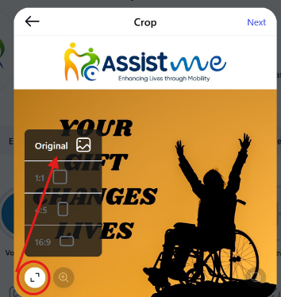
We’ve created ready-to-use social media posts you can download through www.assistmenc.com/events and share on Facebook, Instagram, and LinkedIn. These posts make it easy to spread the word and help your team climb the leaderboard. Reminder: for Instagram, open the arrows in bottom left corner and select “Original” so that it will size appropriately.

When you share via social media, be sure to first follow Assist ME (also known as Assist M.E.) then tag us so we can amplify your message:
- Facebook: #assistme
- Instagram: #assistmenc
- LinkedIn: Tag the Assist ME organization page directly
Add your team name, team link, or QR code to make donating effortless

Here are some sample (thumbnails) of social media posts, logos and official flyer that you can access on Assist ME event page. You are also welcome to share posts directly from our social media sites. If you’d like to create your own social media posts, please visit our Media and Resources page to review branding guidelines and download logos.
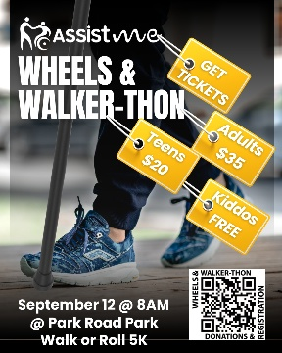
Social Media Posts
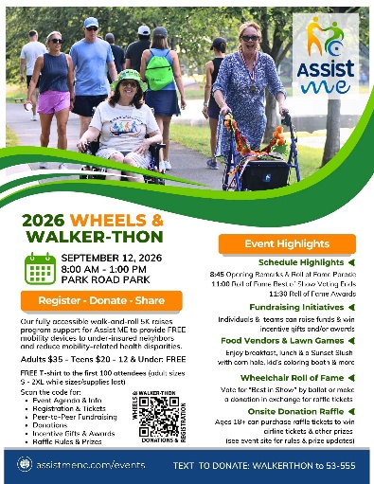
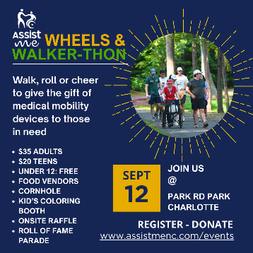
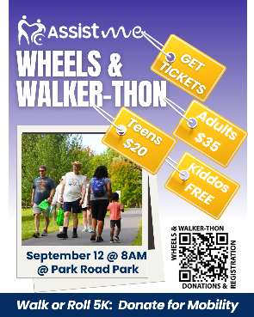
Logos
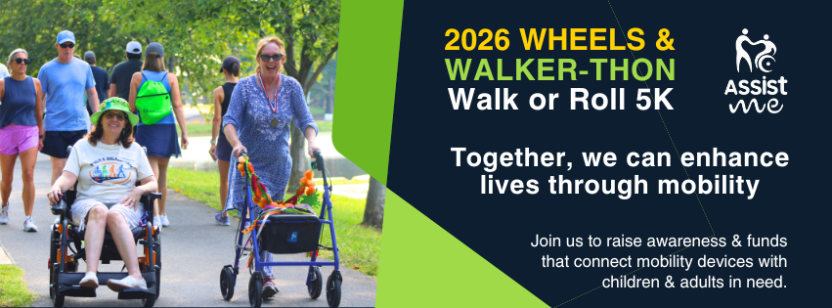
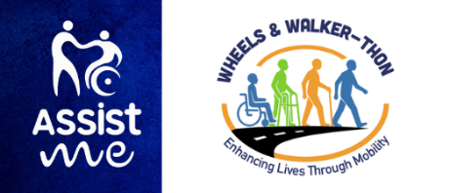
Thank you for being a part of our 2026 Wheels & Walker-thon FUNdraising crew! Incentive gifts will be announced in the following weeks for top achievers. We hope you are one of them! Have more questions? Details can be found at www.givebutter.com/2026Walker-thon
Flyer
Facebook Cover/Banner

