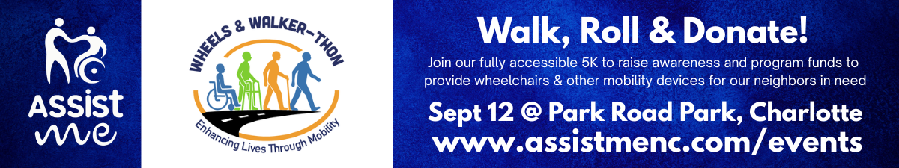
⭐ PEER-TO-PEER FUNDRAISING TOOL KIT

Thank you for joining our peer-to-peer fundraising team! We are excited to have you be a part of Assist ME’s 2026 Wheels & Walker-thon signature event. We’ve developed a checklist, social media, email and text content that you can customize with your team’s name, link and QR Code and then cut and paste as needed to build to your fundraising goal. Best of luck!

⭐ Fundraising Captain Intro
Your friends and family want to support you — they just need reminders. It’s normal. People pledge to donate, then get distracted and never make it onto your leaderboard. That’s why follow-ups matter.
Use the messages below to keep your team’s momentum strong. Add your team name, team link, or QR code, and don’t forget to share your fundraising goal. Clear goals motivate people to give.

⭐ Team Captain Checklist
- Register your team at https://givebutter.com/2026Walker-thon
- Create your team name and set your fundraising goal
- Write your short team story — passion drives pledges
- Share your team link or QR code (save your QR code to your phone)
- Send your first message using the toolkit (below & visit https://assistmenc.com/events/ for updated social media posts)
- Follow Assist ME or Assist M.E. on Facebook, Instagram and LinkedIn – tag us in your posts!
- Post on social media to boost visibility
- Follow up with reminders — people forget, gentle nudges work (really!)
- Thank donors quickly to encourage more giving
- Celebrate milestones to keep momentum
- Stay competitive — leaderboard bragging rights are real
Let your team know you’re aiming to raise the most money for mobility access. You might even win great incentive prizes in the process (stay tuned)!

⭐ COPY & PASTE FUNDRAISING MESSAGES:
(Choose any — mix, match, repeat as needed)
🚶‍♀️ YOUR PEER-TO-PEER COPY & PASTE FUNDRAISING MESSAGES
(Choose any — mix, match, and repeat to keep your network engaged – feel free to customize in a way that engages your family and peers!)

Messages for Captains (Recruit Walkers + Donors)
Option 1:
I hope you can help my fundraiser!
Did you know it can take up to 30 days for insurance to approve a doctor-prescribed wheelchair? That’s 30 days of a neighbor being trapped in a hospital bed or unable to safely leave their home. You’d be surprised at the number of individuals who don’t have the access, finances and insurance coverage to buy a wheelchair or shower chair! I’m walking/rolling in Assist ME’s 2026 Wheels & Walker-thon 5K on Sept. 12th to bridge that gap. Join me at Park Road Park or donate under my team [TEAM NAME] to get someone moving today. [TEAM LINK]
Option 2:
I need your help with a fundraiser! Did you know that insurance will often pay for a walker, but they won't cover a shower chair, wheelchair or a hospital bed when you have a low income and little-to-no insurance? Imagine not being able to safely take a shower in your own home or make it to the bathroom in time! I’m participating in the 2026 Wheels & Walker-thon on Sept. 12th at Park Road Park to help Assist ME continue to provide free, vital mobility equipment such as wheelchairs, bedside commodes and rollators to low income and uninsured families in the Charlotte region. Join my team to walk or roll the 5K or donate to [TEAM NAME] to restore someone’s independence. [TEAM LINK]
Option 3:
Over 110,000 adults in Mecklenburg County are completely uninsured with many more living with substantially low incomes. When they suffer an injury or illness, they are left stranded without the medical mobility equipment they need to recover. I'm rolling/walking in the 2026 Wheels & Walker-thon 5K to help the long-standing Assist ME nonprofit buy and distribute medical mobility equipment such as wheelchairs, tub transfer benches, rollators and hospital beds. Walk or roll with me at Park Road Park on Sept. 12 or drop a donation under [TEAM NAME]! [TEAM LINK] to help me and Assist ME meet our fundraising goals!
MESSAGES FOR DONATIONS ONLY
Option 1:
I’m captaining a fundraising team for Assist ME’s 2026 Wheels & Walker-thon because basic human mobility shouldn’t be a luxury for low income children or adults with little-to-no insurance! The organization is 99% volunteer-powered, meaning your donation goes directly to medical mobility equipment and program costs. Help my team [TEAM NAME] hit our goal:
- $55 covers a tub transfer bench
- $155 provides one 18” – 22” wheelchair
- $500 funds a bariatric wheelchair.
- Any and every dollar brings a Charlotte neighbor home from the hospital or out into the community sooner and with dignity. Please donate here: [TEAM LINK]

Option 2:
The healthcare system has massive gaps. If a Medicaid recipient's wheelchair wears out within 5 years, they are entirely on their own. Assist ME is the safety net that steps in when the system fails. I'm leading a fundraising team for the 2026 Wheels & Walker-thon Fundraiser (Sept 12th at Park Road Park if you’d like to register!) to keep their stock filled. Please support [TEAM NAME] with a donation today—let's make sure no neighbor is left bedridden. [TEAM LINK]
Option 3:
Basic safety at home shouldn't depend on your paycheck and insurance status. Assist ME provides free mobility equipment to neighbors in the Charlotte region who are uninsured and stuck in insurance red tape – including Medicaid delays. I'm raising funds to support their volunteer-driven mission. Support my 2026 Wheels & Walker-thon team [TEAM NAME] and give the gift of mobility to children and adults in need of wheelchairs and hospital beds: [TEAM LINK]
The "Nudge" & Reminder Messages (For Everyone)
Reminder 1: The Leaderboard Push
We are climbing the leaderboard for the Assist ME 2026 Wheels & Walker-thon, but we aren't there yet! Did you know over 12% of adults in Meck County are uninsured? A $75 donation to [TEAM NAME] ensures that an uninsured neighbor with a low income doesn't miss a doctor's appointment because they lack a Rollator or $155 to purchase a wheelchair. Any dollar amount is appreciated and helps us finish strong: [TEAM LINK]
Reminder 2: The "Last Call" Urgency
The September 12th Wheels & Walker-thon walk-or-roll 5K fundraiser is almost here! If you haven't had a chance to donate to [TEAM NAME] yet, this is your moment. Your gift directly bypasses financial and/or insurance delays and puts wheelchairs, bedside commodes, and hospital beds directly into the hands of families who need them right now. One click can change a life: [TEAM LINK]

2 EMAIL TEMPLATES
Subject: It can take up to 30 days to get a wheelchair. Let’s change that.
Hi [Name],
Imagine being medically cleared to leave the hospital, but you can’t actually go home or leave home because you can’t walk—and you don’t have the finances or insurance to cover a wheelchair.
Even for those with Medicaid coverage, approvals for prescribed mobility equipment can take up to 30 days. That is an entire month of a neighbor being trapped in a hospital bed, delaying their recovery, and risking dangerous falls or increased ER admittance rates.
I am participating in Assist ME’s 2026 Wheels & Walker-thon on September 12th to change this reality for children and adults in the greater Charlotte region.
Assist ME provides free, essential mobility equipment—like wheelchairs, tub benches, and walkers—to individuals with low incomes AND little to no insurance. They bridge the terrifying gap between hospital and home. Because they operate almost entirely through volunteers, financial donations go directly toward direct program costs and the purchase of highly depleted equipment so that no neighbor is ever turned away in their moment of need.
I have set a team fundraising goal of $[INSERT GOAL] under my team, [TEAM NAME], and I need your help to cross the finish line.
How you can help today:
- Donate: Click my team link [TEAM LINK] to make a fast, secure donation.
- Join Us: Register to walk or roll with me at Park Road Park on September 12th! Tickets are available at www.assistmenc.com/events.
A single piece of equipment—like a shower chair that allows an adult to bathe with dignity—or a bedside commode can be completely life-changing. Thank you for helping me bring independence and safety within reach for our most vulnerable neighbors.
Enhancing lives through mobility—together.
Sincerely,
[YOUR NAME]
EMAIL REMINDER
Subject: Quick nudge about the Walker-thon! Did this get lost?
Hi [Name],
I know how fast inboxes fill up, so I wanted to gently bump this back to the top of your pile!
In case you missed my last note, I’m raising funds for Assist ME's Wheels & Walker-thon on September 12th. This 99% volunteer nonprofit does incredible work in our community by providing free mobility equipment like wheelchairs and hospital beds to neighbors facing low incomes and insurance gaps, or experience long Medicaid delays. Imagine not being able to go home from the hospital without equipment you need to safely navigate healing and life?
My team, [TEAM NAME], is trying to raise $[Amount] to provide mobility equipment directly to children and adults who are currently stuck waiting in hospital beds or their homes due to acute, chronic or end-of-life transition care needs.
$55 pays for a tub transfer bench. $155 pays for one wheelchair. Would you be open to chipping in $25 or $50 today to help me hit my goal?
Here is my quick donation link: [TEAM LINK]
Thank you so much, I really appreciate you!
Best,
[YOUR NAME]

📣 Social Media Reminder – follow us and post on your platforms:
We’ve created ready-to-use social media posts you can download at www.assistmenc.com/events and share on Facebook, Instagram, and LinkedIn. These make it easy to spread the word and help your team climb the leaderboard. For Instagram, be sure to tap the arrows in the bottom left corner and select “Original” so the image sizes correctly.

When posting, follow Assist ME (also listed as Assist M.E.) and tag us so we can amplify your message:
• Facebook: #assistme
• Instagram: #assistmenc
• LinkedIn: Tag the Assist ME organization page

Add your team name, team link, or QR code to make donating effortless.
You’ll find sample posts, logos, and the official event flyer on the Assist ME event page. You’re also welcome to share posts directly from our social media pages. If you prefer to create your own, visit our Media and Resources page for branding guidelines and downloadable logos.
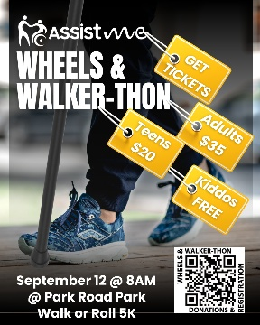
Social Media Posts
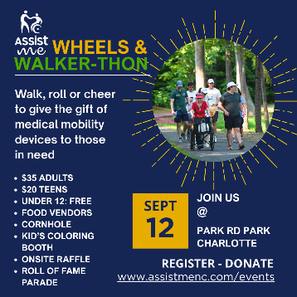
Logos
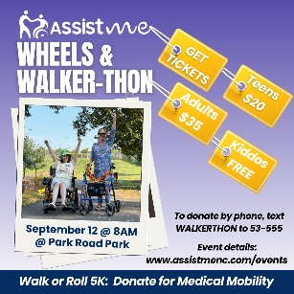
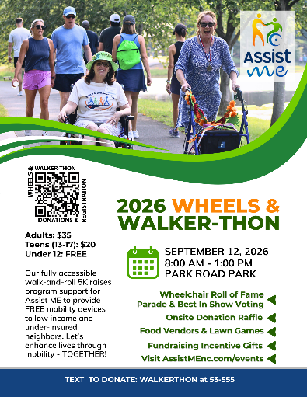
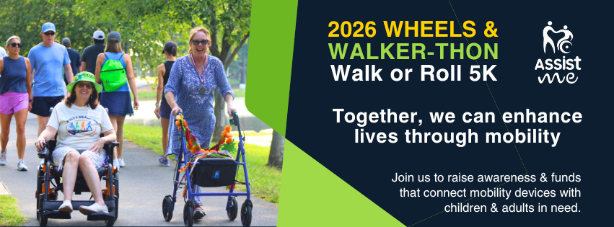
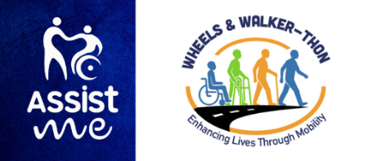
Thank you for being a part of our 2026 Wheels & Walker-thon FUNdraising crew! Incentive gifts will be announced in the following weeks for top achievers! We hope you are one of them! Have more questions? Details can be found at www.givebutter.com/2026Walker-thon
Flyer
Facebook Cover/Banner

